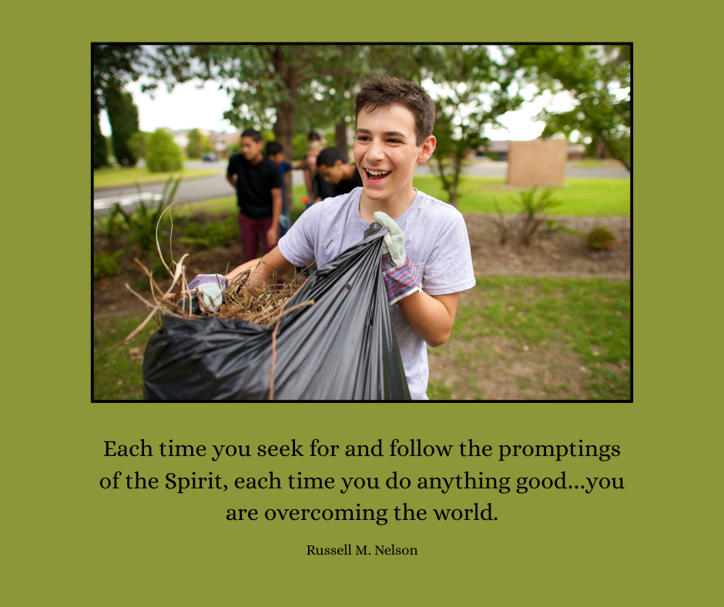

Image available here: [Service](https://www.churchofjesuschrist.org/media/image/youth-service-project-6adf6e1?lang=eng&collectionId=6314efa423f448c9bd67420a1acc836e&fbclid=IwY2xjawKhPuBleHRuA2FlbQIxMABicmlkETFpT2lNRWthd090bDRTNnpwAR4gIMRC26wQyJPir-H7hnmseqpT0xLQmu9QhU8OggOVgnZnAaIaYlCuN5hMTQ_aem_2YoQIKhO9fXkpDrI-edgNw)