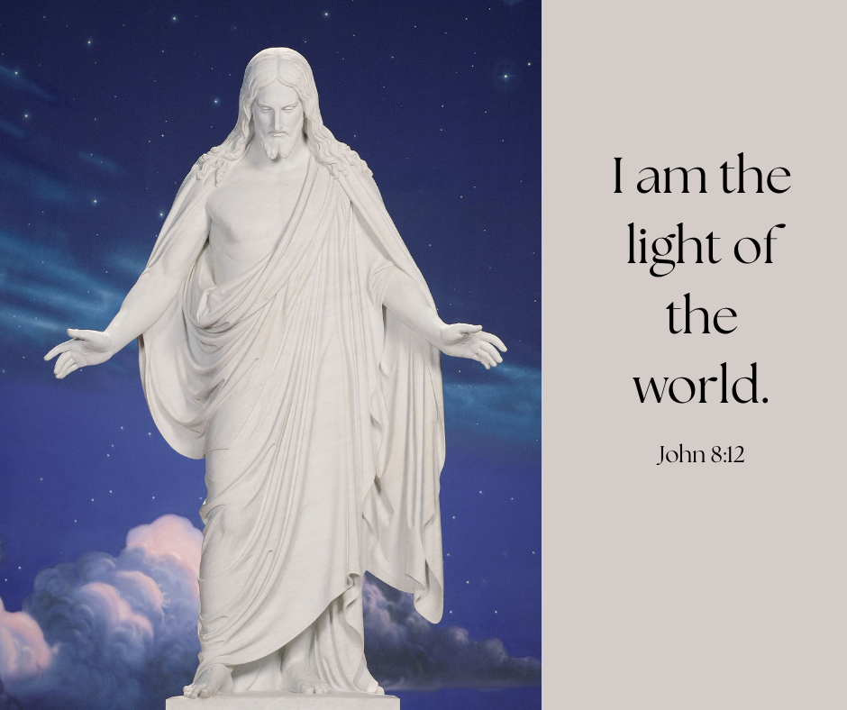

Image available here: <https://www.churchofjesuschrist.org/media/image/christus-statue-visitors-center-b6c9c03?lang=eng&collectionId=3cbf78e787498a07417814a31656063f9227b4c6>