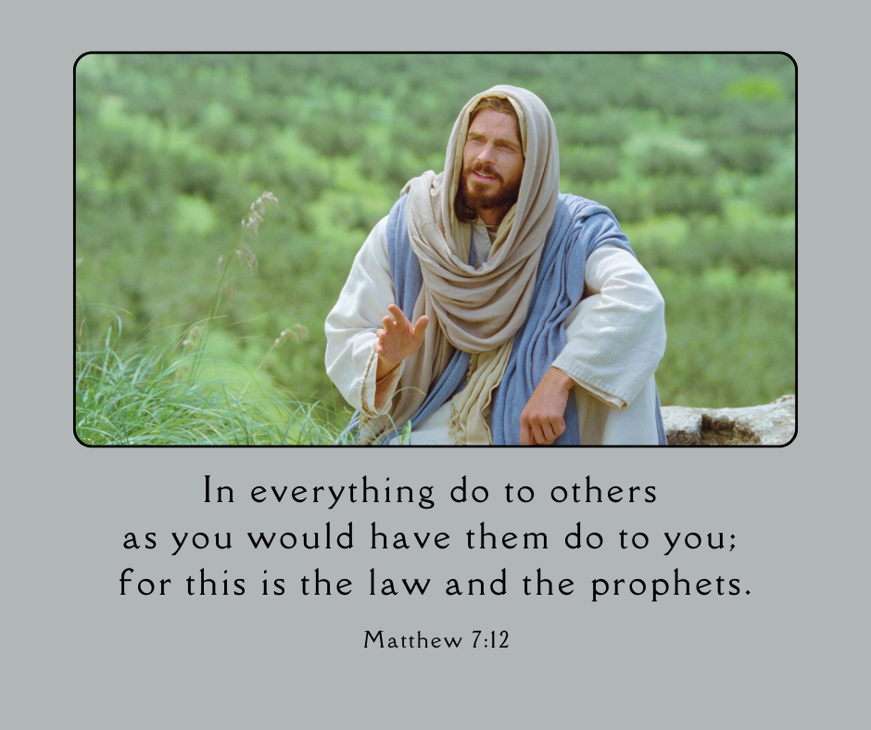
Image found here: Ye Have Done It unto Me

