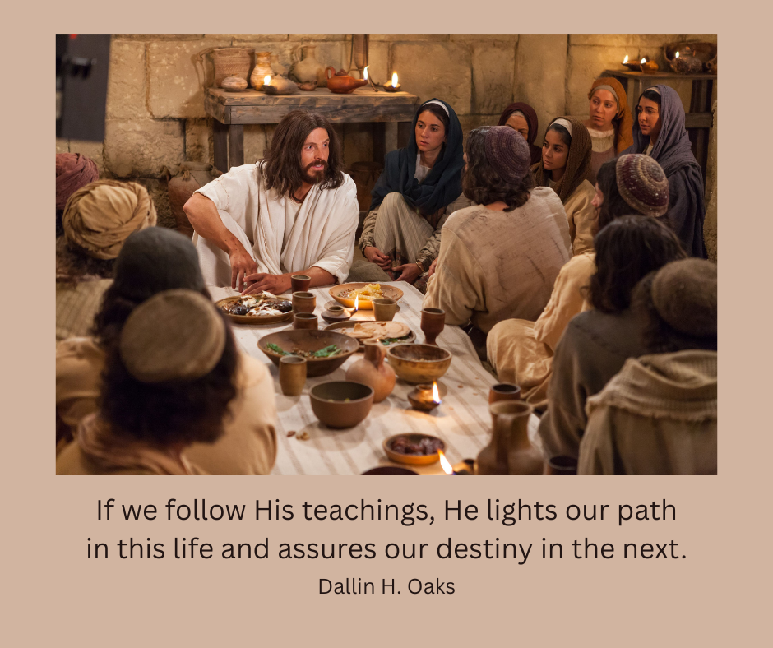

Image available here: <https://www.churchofjesuschrist.org/media/image/resurrection-jesus-appears-apostles-df066c2?lang=eng&collectionId=540325ab91d18e0e1e52262aac51c33c10c4724b>