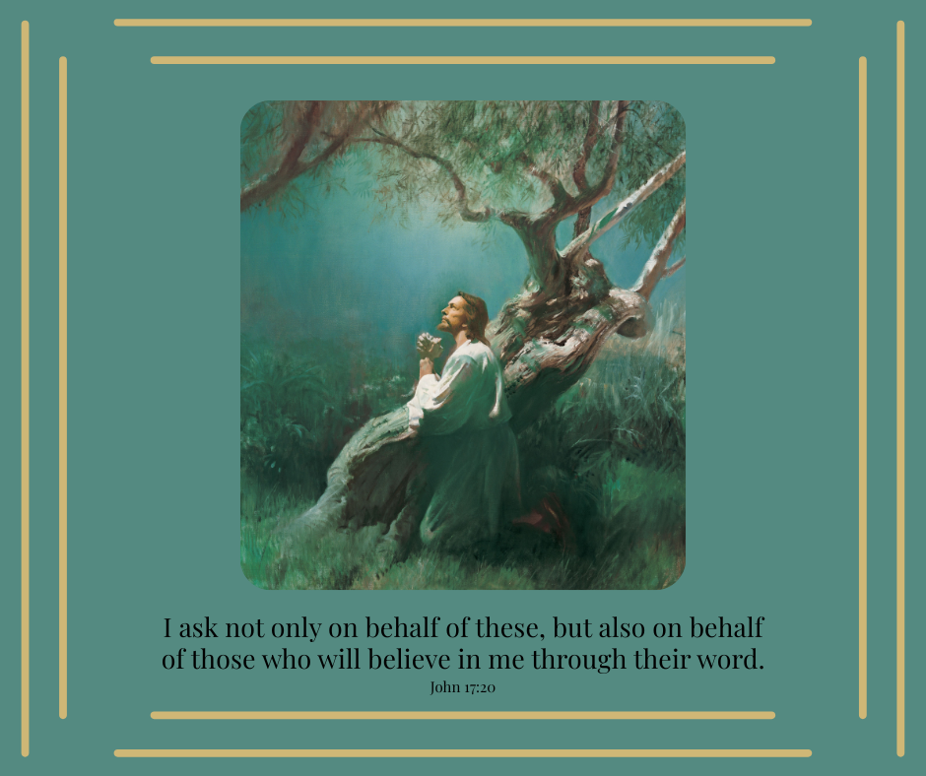

Image found here: Jesus Praying in Gethsemane (Christ in Gethsemane)

