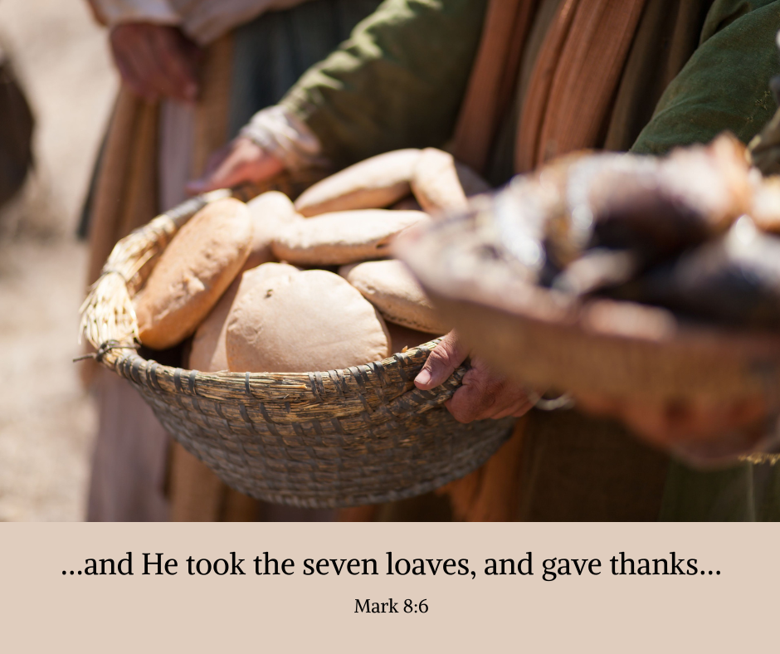

Image available here: <https://www.churchofjesuschrist.org/media/image/miracles-of-jesus-feeding-5000-bread-a54cbae?lang=eng&collectionId=ce0e582d094a66ead9b1cf41dd1581436fcf8982>